# **Blood Bank Management System**

# 

Group 28:

Muhammad Shahrukh - 2020-10-0287

Syed Usman Samee - 2020-10-0067

Muhammad Taha - 2020-10-0123

Muhammad Asad - 2020-10-0216

# Updated Schema:

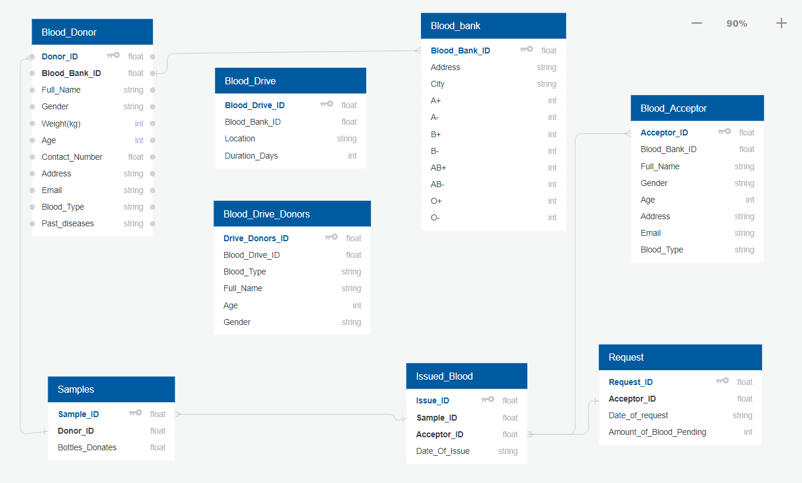

Schema after normalization on next page:

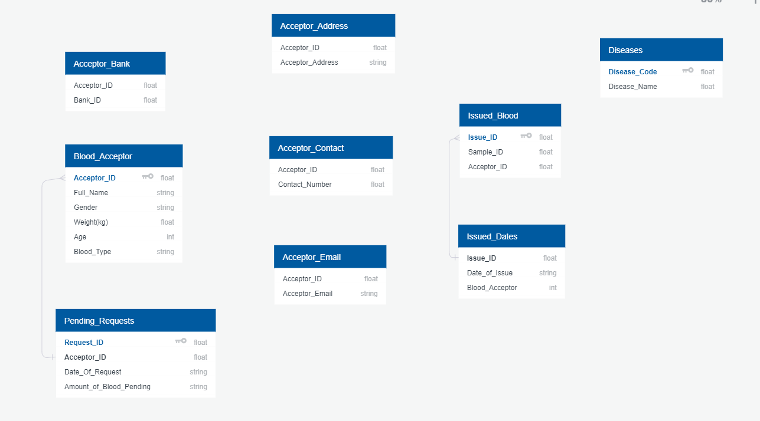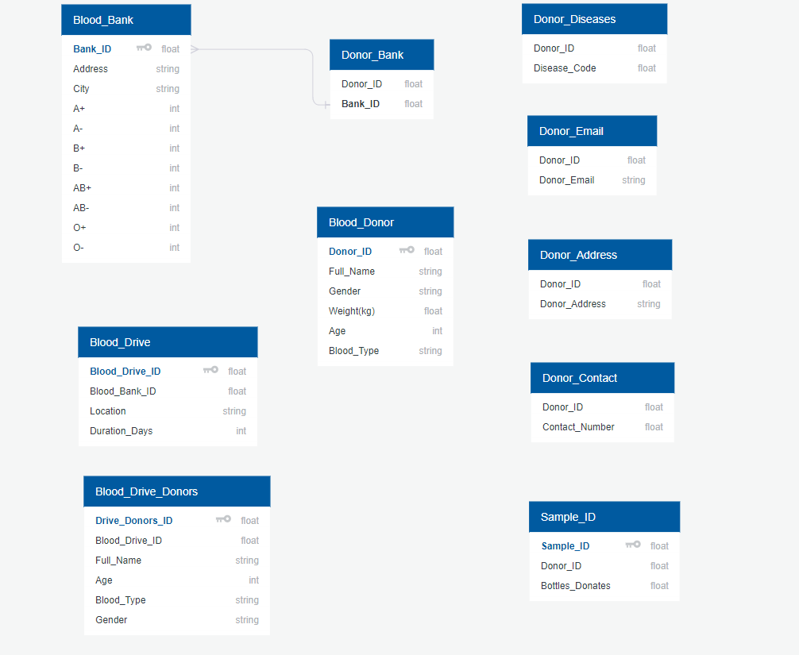

# Updated EER Diagram:

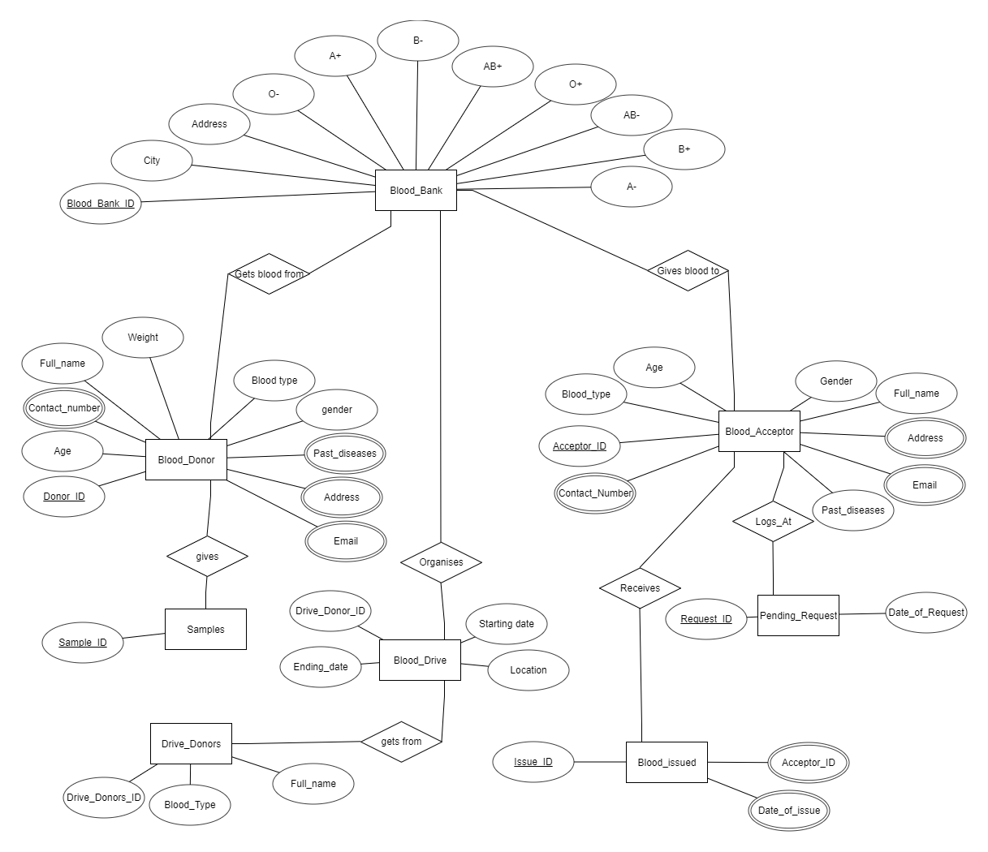

**Queries**

Query 1

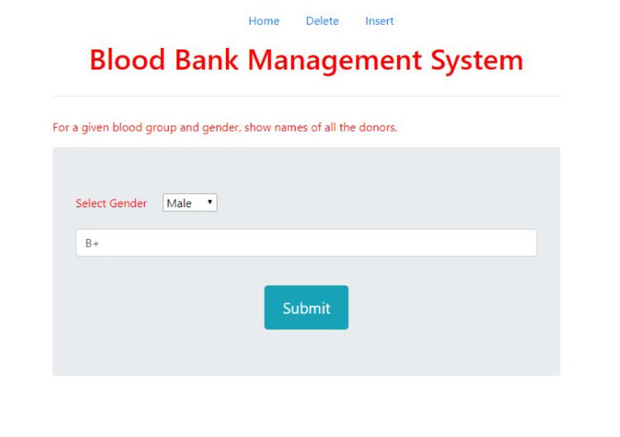

Result:



Query 2:

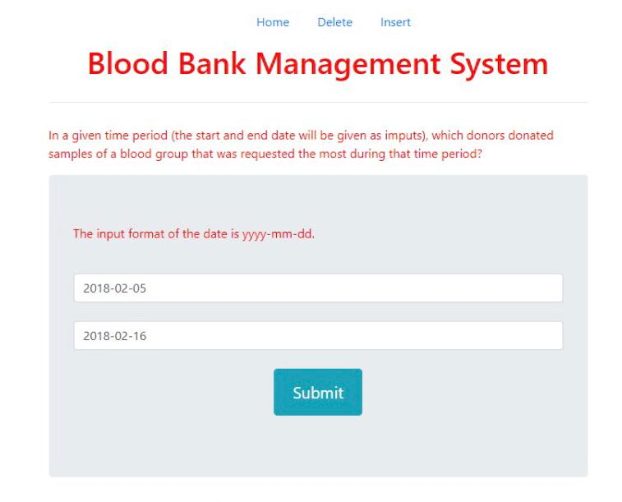

Result:

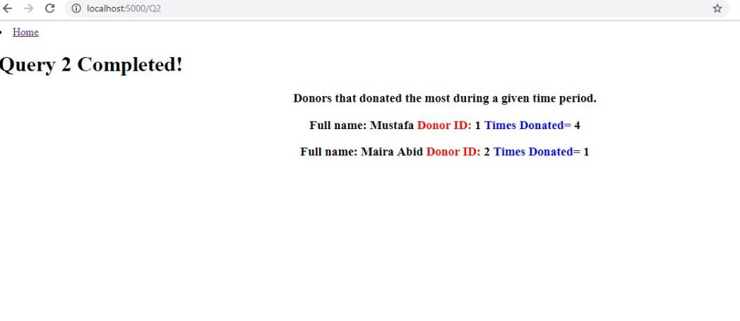

Query 3:

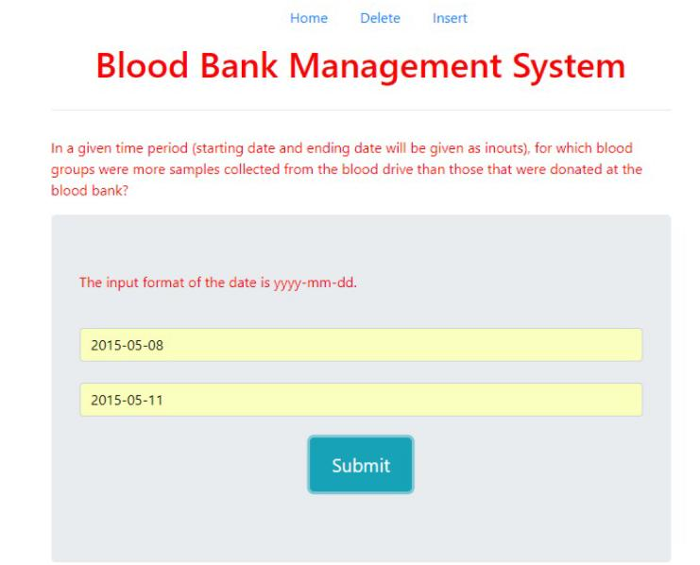

Result:

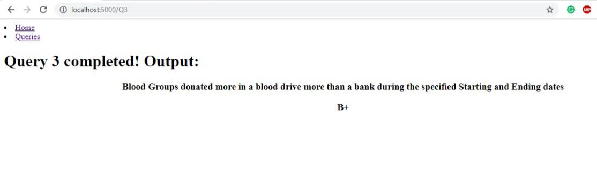

Query 4:

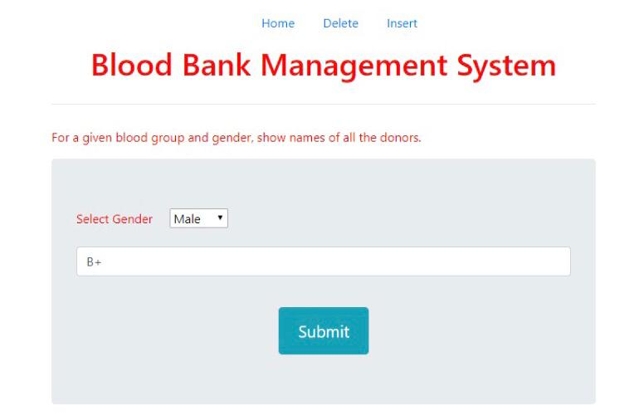

Result:

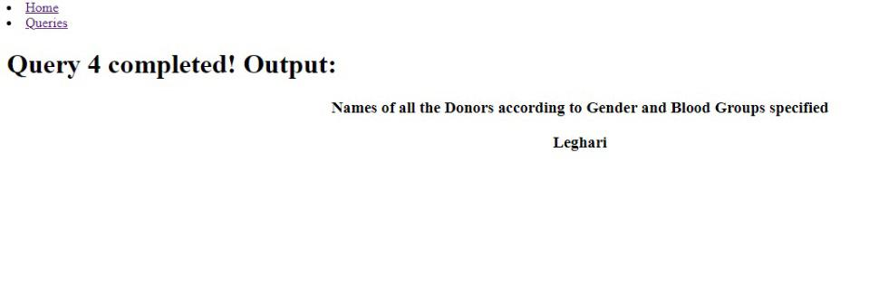

Query 5:

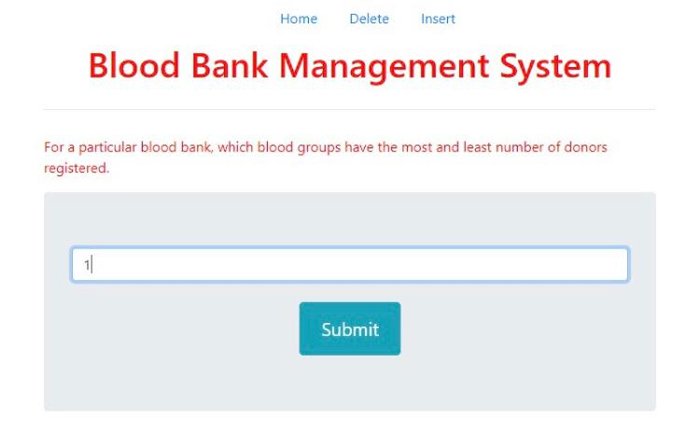

Result:

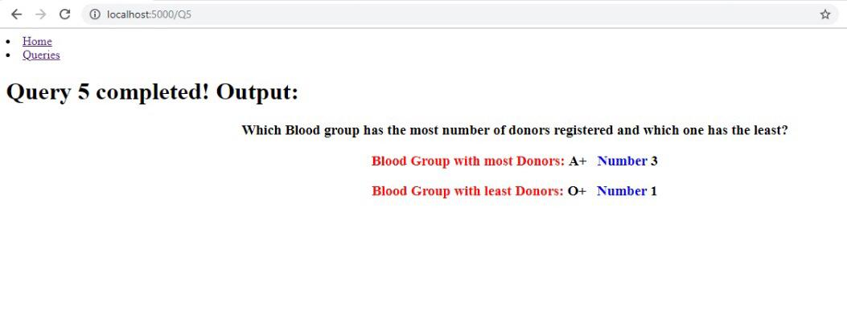

Query 6:

Result

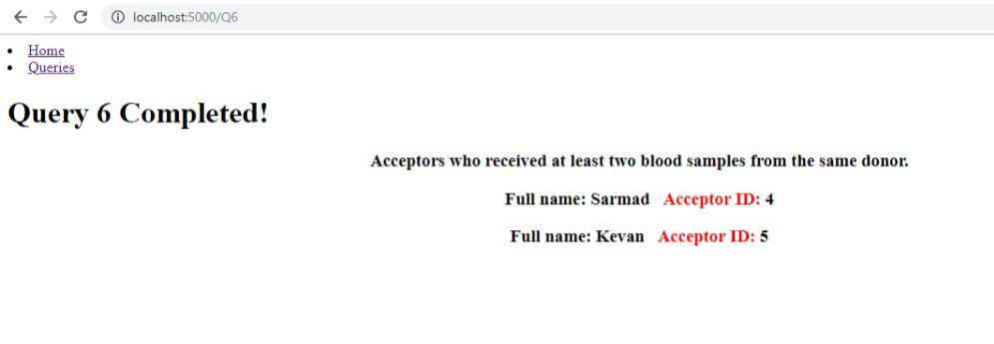

Query 7:

Result

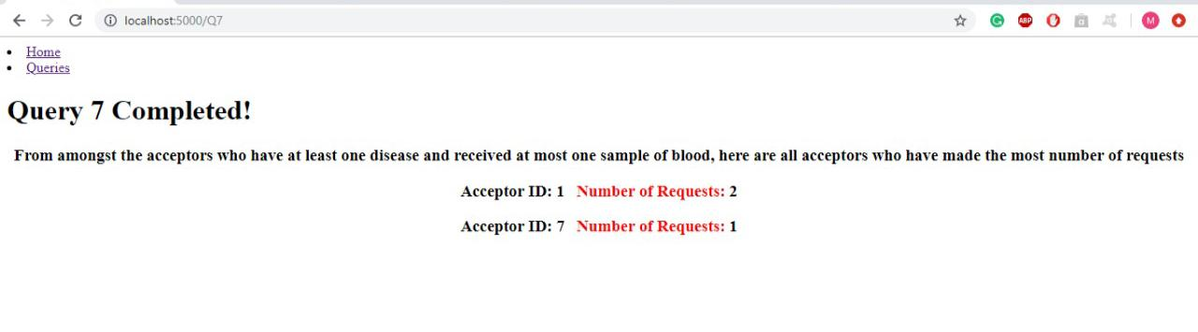

Query 8:

Result:

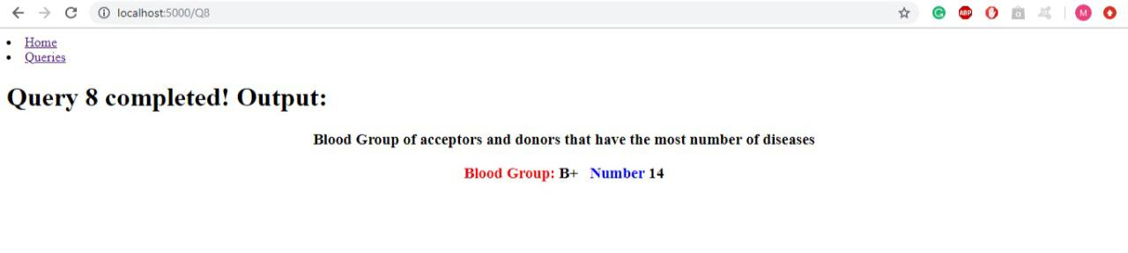

Query 9:

Result:

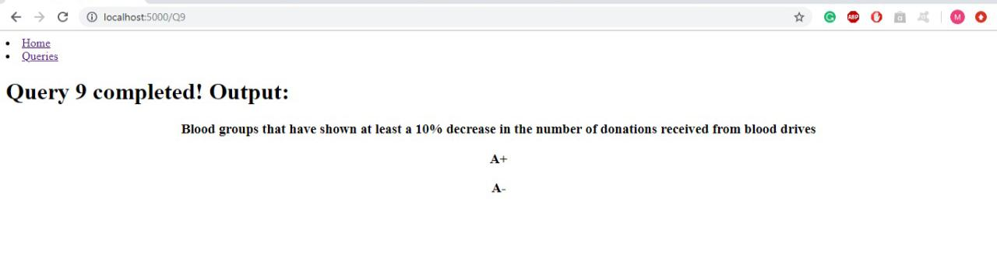

Query 10:

Result:

